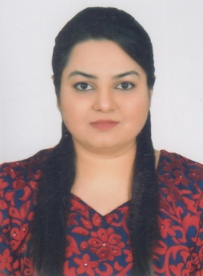
DR. IFRAH SABA
House No. 10-A, Wallayat Abad Colony No.2, Vehari Road, Multan.
Phone: 0331-7008207
E-mail: ifrah_saba1987@yahoo.com

OBJECTIVE

To obtain a challenging, highly motivated and demanding job that will further enhance my knowledge and medical skills, and where I can add value to the system. I have a clear, logical mind with a practical approach towards the treatment and care of my patients. I enjoy working on my initiative or in a team. In short I am hardworking and always ready to learn and teach.

WORK EXPERIENCE

House Officer
NISHTAR HOSPITAL MULTAN
- Gynae & Obs | 3 months | 25-08-18 to 24-11-18
- General Surgery | 3 months | 25-11-18 to 24-02-19
- General Medicine | 3 months | 25-02-19 to 24-05-19
- Psychiatry | 3 months | 25-05-19 to 24-08-19
General Internship
- 01st of August 2013 to 31st of March 2014 Nishtar Hospital, Multan.

EDUCATION

HIGHER SECONDARY SCHOOL – 2005-2007
PUNJAB GROUP OF COLLEGES FOR WOMEN, MULTAN, PAKISTAN secured 738/1100 as per equivalence certificate
BACHELORS OF MEDICINE AND BACHELORS OF SURGERY 2009-2014
XIAN JIAOTONG UNIVERSITY, CHINA

INTEREST

- New medical researches
- Attending workshop
- Sports activities like shot-put throw, video games, gardening & geography.

REFERENCES

- Available on request

