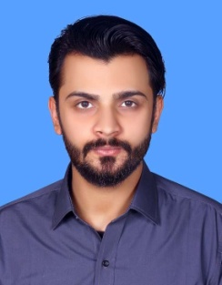
RAKHSHAN MALIK
House # 2/13 B Area Liaquatabad Karachi.
Contact No. 0315-2403771
Email:rakhshanmalik31@gmail.com
PROFESSIONAL OBJECTIVES:
To seek a challenging position in a reputable, progressive and growing organization,
Were, I may be able to utilize my skills, and abilities with an opportunity of growth,
Advancement and enhancement of my knowledge and practical experience.

ACADEMY QUALIFICATION.
- Matriculation in (Science) from Karachi Sindh Board (2010)
- Intermediate (Pre-Engineering) from Karachi Sindh Board (2012)
- B.S (Honor) in Physics from University of Karachi (2016)
- MSC in Physics with 1st Division from University of Karachi (2017)
PROFESSIONAL EXPERIENCE.
- Currently Teaching at The Inspiration Model School-09 since 2018
OTHER SKILLS

- Mathematics & Physics Teacher
PERSONAL PROFILE.
Father’s Name : Muhammad Yaseen Malik
Date of birth : 31 October 1992
C.N.I.C No : 42101-9880066-7
Marital Status : Married
Religion : Islam
Nationality : Pakistan
Domicile PRC : Karachi (Sindh)
Language : Urdu,English

REFERRENCE.
Reference could be furnished on demand.

