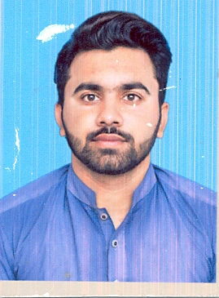 |  | Kamran Liaqat  OBJECTIVE:  Seeking a challenging assignment, affording the prospect of making a difference by utilizing my abilities and professional exposure in the corporate environment of a leading company where self-start, innovation is encouraged and it provides boundless future growth based on one’s performance.  EDUCATION:  2020  M.Com(Commerce) Riphah international University Islamabad - CGPA (3.98/4.0)  2018  B.COM (Commerce) Riphah international University Islamabad  CGPA (3.87/4.0)  2013  FSC (Non-Medical) Faisalabad Board  (1st Division)  2010  Matriculation (Science)Faisalabad Board  (1st Division)  PERSONAL INFORMATION:  Father’s Name : Liaqat Ali  Date of Birth : 05th Octoberr-1994  Marital Status : Unmarried  Religion : Islam  Citizenship : Pakistan  Domicile : Punjab (Faisalabad)  CNIC : 33105-6598593-9  Address : House # 89, Kehkishan Colony, Street #  3, Samundri.
CONTACT
 0305-9259578 | ,
LANGUAGES
English, Urdu
Urdu
SKILLS
- Self-motivated and initiative oriented.
- Ability to grasp concepts and logic quickly.
- Capable of handling challenging and difficult situations under pressure.
- Strong Interpersonal skills.
- To contribute my best and achieve the goals and objectives of the organization.
INTERESTS
- Reading Islamic Books
- Gain Knowledge
- Tours
COMPUTER SKILLS
- Diploma of Microsoft Office.

REFERENCES:-
- Will be furnished on demand.

