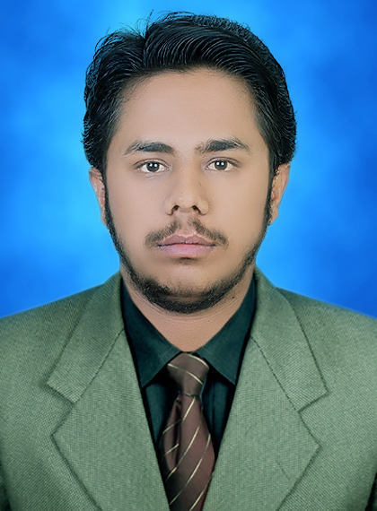 |  | Riaz Ahmed Channa  OBJECTIVE  My mission is to make things according to the Higher Accuracy honour and having huge proud and confident on them  ------------------------------------------------------  PERSONAL  Fathers Name: Akhtar Muhammad Channa  Date of birth: 6thFebruary 1994  C.N.I.C: 43304-5387882-7  Marital Status: Single  Nationality: Pakistani  Domicile: Shikarpur  Religion: Islam  ------------------------------------------------------  EDUCATION  Matriculation  Govt: Qazi Habibullah Higher Secondary School Shikarpur 2009-2011  Intermediate  Govt: Qazi Habibullah Higher Secondary School Shikarpur 2011-2013  Bachelor of Computer Science  Shikarpur Campus, Shah Abdul Latif University  2015-2018  ---------------------------------------------
CONTACTS:
.................................…
0333-1364620

riazahmedchanna.1994@gmail.com

ADDRESS:
....................................
H.NO:12/686Ghagharani Street Near Lal Muhammad Advocate House Sheikh Mohalla Shikarpur
SKILLS:
........................................
- PHP5
- Bootstrap 4
- MySQL Database
- HTML5
- CSS3
- Microsoft Office
- Java
- C Language

LANGUAGES SKILLS:
......................................................
ENGLISH, URDU, SINDHI

OTHER ACTIVITEIS:
.................................................
Reading Books, Novels

