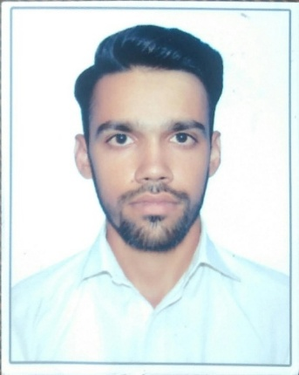
Personal Data:
MUHAMMAD YAQOOB
F/N: MANIR KHAN
Mobile No: 03365494613
Email: yaquobkhan344@gmail.com
EDUCATION:
- Matric In (Computer Science).
- INTERMEDIATE EDUCATION( CARRYING).
- WORK ON DBA(Diploma In Business Administration).
EXPERIENCE:
- Waiter/Table Man

OTHER EXPERIENCE:
- Ms. Word
- MS. Excel
- Data Entry
Languages:
- English
- Urdu
- Pashto

