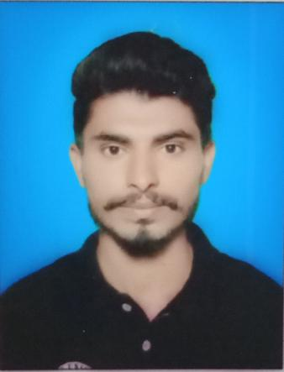
Zabair arshad
Street No.2 Madina Colony Marzipura Burewala distt. Vehari
Cell phone#: 03099968885
Email address: zabairarshad315@gmail.com

Objective
Take your career opportunity and do the best of me to give a successful for your company.

Personal information
Father Name: Arshad Mahmood Birth place: Burewala
Date of Birth: September 8, 2000 Status: Single
Age: 20 Religion: Islam
Gender: Male Occupation: Student

Education
2017-continued COMSATS University Islamabad (Vehari campus)
BS honors (Economics) Last semester (8th)
Major Subject: Economics
CGPA: (2.6)
2014-2017 Leads group of colleges Burewala
ICS
Major Subject: (Computer, Economics, Education)
Marks: (710) percentage: 64%
2012-2014 Govt. M.C Model high school Burewala
Matric
Major Subject: (Computer, physics chemistry)
Marks: (500)

Awards and extra skills
Skills
- Ms office Word
- Ms office Excel
- Ms office PPowerpoin
Awarded with shield as Punctual student in annual function of Leads college
Certified as a volleyball player in Sports week Award ceremony of COMSATS University
References: Available on request

