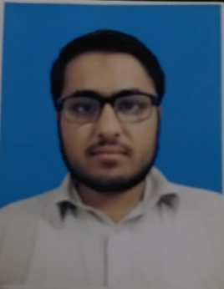
Yasir Ahmad

Email: ya660604@gmail.com

Mob: 03449603074

Address: Village Marwatan banda P/O khojaki kala Distt.Karak kpk.

Professional Objectives
“To work In a dynamic organization or institute where efforts are recognized and rewarded through elevation in starts and where sample opportunities for learning and career advancement exist & to ensure efficient and utilization in Social Sides. Goal Oriented, Analytical Approach, Quick Learner, Adjustable, Team Worker, can work well in stressful condition, good communication, and writing skills.”

Personal Profile

Father Name: Naushar khan
DOB: Sep, 30, 1997
NIC no: 14203-8821410-7
Nationality: Pakistani
Present Location: Karak
Religion: Islam
Marital Status: Single
Languages: English, Urdu,pushto

Qualification

Qualification | Name of Institute | Subject | Year | Grade/%
BS English | Kohat University of Science & Technology | English linguistics and literature | 2021 | 2.6 CGPA
HSSC | Kohat Board | Medical | 2016 | A1/ 81.1%
SSC | Kohat Board | Science | 2014 | A/ 71.35%

skills.
1 Teaching
2 Admin section
3 Management
4 Sportsman

Distinguish Features

- Can work for long hours
- Flexible and Amazing ideas.
- Can take challenges with confidence
- Ambitious
- Capable to teach in an effective manner
- Under take responsibilities easily and confidently
- Good relationships building skills

Sports
- Cricket
- Football

